University of Pittsburgh, Department of Psychology
2017-2018 Colloquium Series – Spring 2018

January 19 – Tim Rogers, Ph.D.
Title: “Connecting Natural and Artificial Neural Networks in Functional Brain Imaging”
http://psych.wisc.edu/Rogers/
Professor of Psychology, University of Wisconsin, Madison.

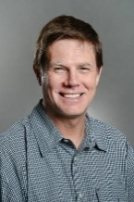
March 2 – Timothy Trull, Ph.D.
Title: “Ambulatory Assessment in Psychopathology”
https://psychology.missouri.edu/people/trull
Professor of Psychological Sciences
University of Missouri

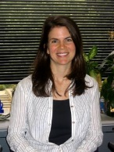
April 6 – Melissa Ferguson, Ph.D.
Title: “Can we change our implicit mind? New social-cognitive evidence for when and how we can undo our implicit first impressions”
http://www.psych.cornell.edu/people/faculty/ferguson-profile/
Professor of Psychology, Chair, Department of Psychology, Cornell University

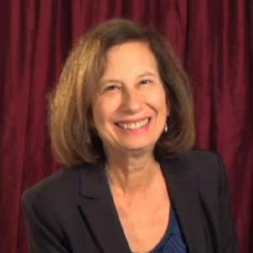
April 13 – Susan Levine, Ph.D. (Sponsored by the Honor’s College)
Title: “The role of cognitive and emotional factors in children's early math learning”
https://cogdevlab.uchicago.edu/directory/susan-levine
Professor in Education and Society, Chair, Department of Psychology
University of Chicago

April 20 - Kenneth Dodge, Ph.D.
https://sanford.duke.edu/people/faculty/dodge-kenneth
Professor of Psychology and Neuroscience
Director of the Center for Child and Family Policy, Sanford School of Public Policy
Duke University

